GUS Portal Instructions – Financial Aid
- Login to the GUS Portal, https://gus.uams.edu, using your UAMS username and password.
- Do not use the back button in your browser! Only use GUS navigation buttons and links.
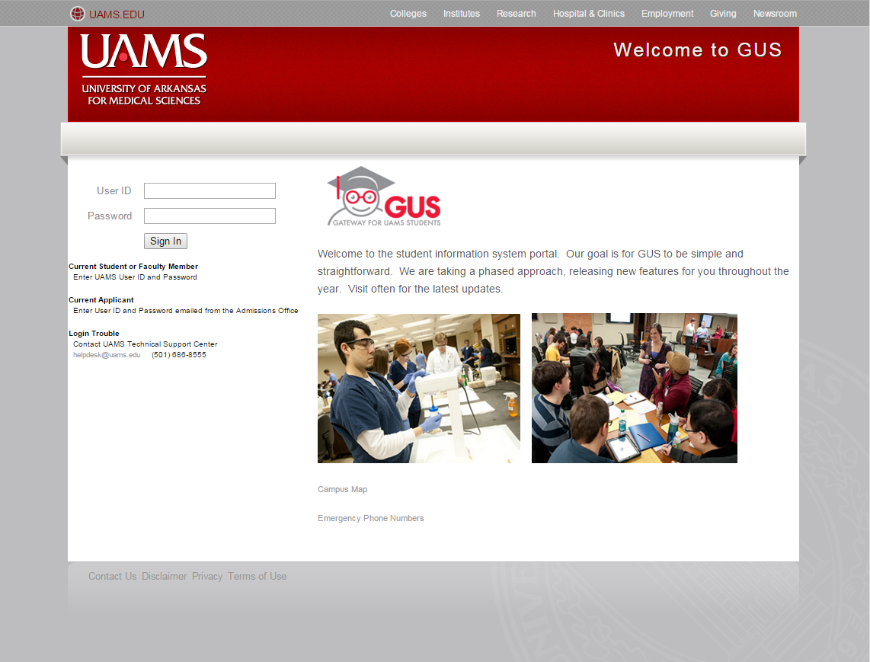
- Once logged in, the portal page will appear. Here you can view various topics regarding your UAMS account including your ‘To Do List’ items. This section includes items from the Financial Aid Office as well as other departments on campus. Note: be sure to click on each ‘To-Do’ item as this will allow you to view more detailed information, forms, etc.
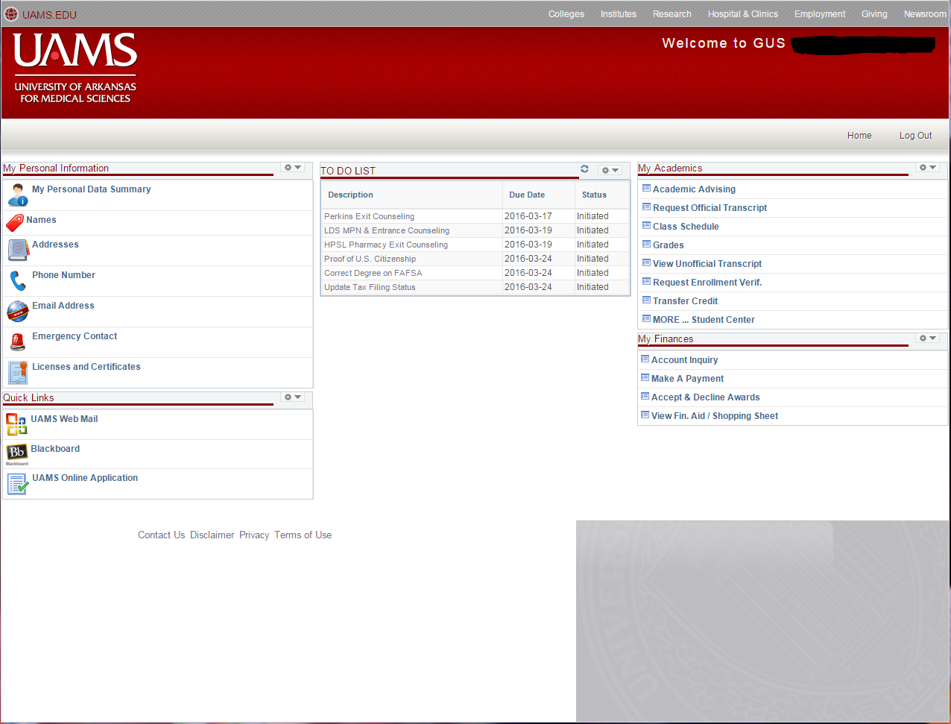
- Once the Financial Aid Office has notified you of your financial aid award package, you can accept/decline the awards, view your account summary and view the Shopping Sheet.

If you have any questions regarding financial aid, please contact the Financial Aid Office at (501) 686-5451 or email us at financialaid@uams.edu.

