GUS Overview: Staff and Faculty Users
Student Records, Transfer Credit and Academic Advising

Welcome to the new Gateway for UAMS Students (GUS), the consolidated student information system for student admission, enrollment, accounting, financial aid and more. Beginning with the Fall 2016 semester, most UAMS students will self-enroll for coursework using GUS. Students in the Colleges of Medicine and Pharmacy will still register for coursework through previous systems. This document provides a general overview of the system, including screenshots for the most common sections for users with student records, transfer credit or academic advising access. Training for admissions, student financials and financial aid is not included in this document.

GUS Security
Access to GUS is limited to UAMS faculty and staff with specific job responsibilities requiring access to student academic records or financial information. Training is required for all faculty and staff users. Visit http://gusinfo.uams.edu for a detailed list of training opportunities. GUS users may have access to confidential student information. GUS users may encounter confidential student information, and agree to be bound by all applicable privacy requirements. GUS is for official UAMS use only; any other use is strictly prohibited and can result in disciplinary action. By logging into GUS, users agree that they understand these guidelines and agree to be bound by applicable UAMS policies regarding access to confidential data.

GUS Homepage
GUS is online at https://gus.uams.edu. Log in using your UAMS Domain user ID and password (the same login credentials used for your UAMS email).
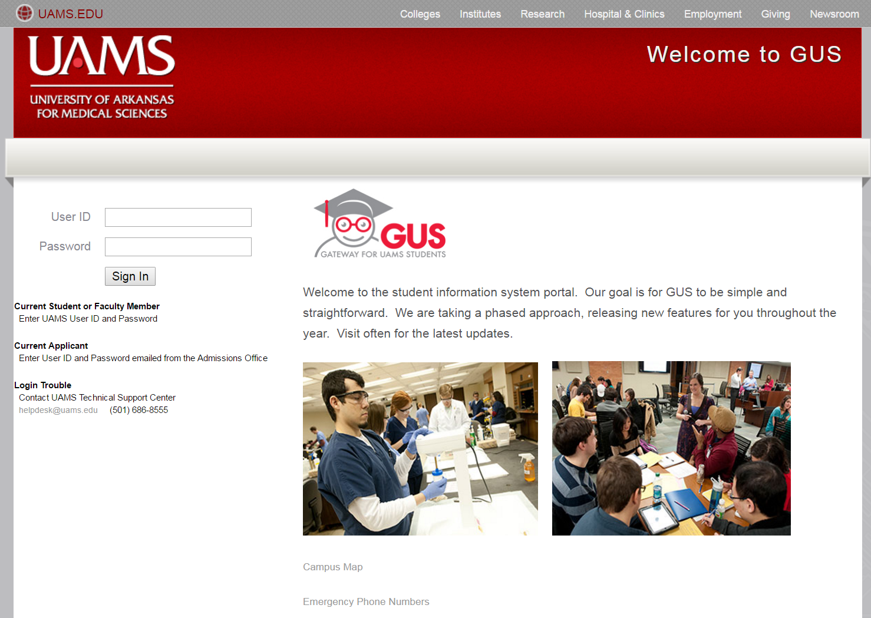

Once you have successfully logged in, you’ll arrive at the general homepage. Remember, you can always click the “home” link in the upper right-hand corner of any “red-banner” page to get back to the homepage:
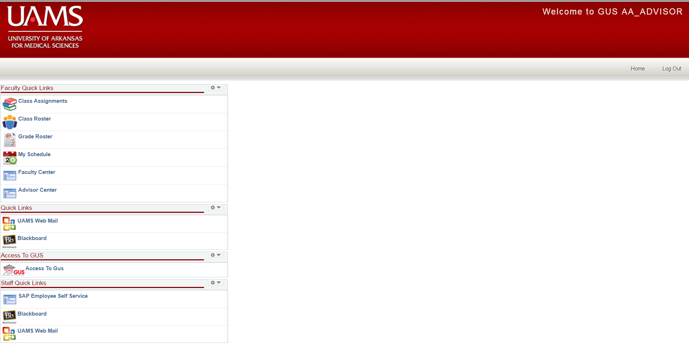
NOTE 1: The screenshot above shows options that may not be available to all users. Please see the descriptions below for more information about what you will be able to see on your homepage.

NOTE 2: After about 20 minutes of inactivity, you will be logged out of the system. For security reasons, it is always good practice to log out of your session when complete. Do this by simply clicking the “Log Out” link in the upper right-hand portion of the page.

Faculty Quick Links
Faculty Quick Links provide access to your primary faculty and academic advising functions, such as courses for which you are an instructor, class rosters, grade rosters and your faculty schedule. In addition, you have access to the Faculty Center and/or the Advisor Center, where additional information is available.
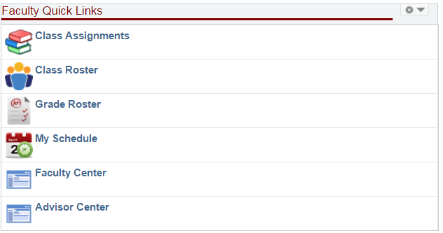

Quick Links
The Quick Links section allows you to access your UAMS email as well as Blackboard.
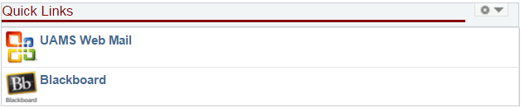

Access to GUS
This link takes you into the deeper functions of GUS. Beware, however, once you enter this portion of the site, you are no longer in the “red banner” portal page. You’ll still have all of the same access, but navigations will look different. Learn more about this functionality in your training session.
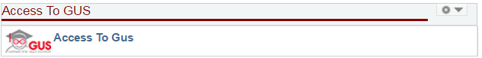

Staff Quick Links
Staff Quick Links generally mirror the Quick Links section above, but not always. The Staff Quick Links section includes a link to SAP Employee Self Service, and other links may vary depending on your staff or faculty role.
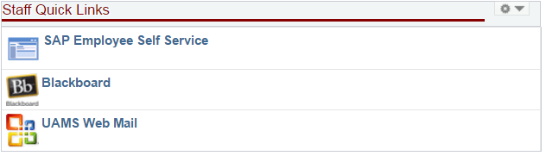

GUS General Reminders and Helpful Hints
Access to GUS is restricted to users who have completed appropriate training. Training information is available at the GUSInfo website: http://gusinfo.uams.edu. RSVP is generally required. At the training

GUS Access & Training
Access to GUS is requested through UAMS ServiceNow Security Forms. Access will not be granted until the user has completed appropriate training. Training information is available at the GUSInfo website: http://gusinfo.uams.edu. RSVP is generally required. At the training session, you’ll learn about the functions appropriate to your role at UAMS. For student records, transfer credit and academic advising access, training sessions are split between three primary categories. As additional training becomes available, additional categories will be created:
- College Administrative Staff. In my current role, I access BART or the COM Student Database to view student information or manage student records, or I directly manage staff who do have this access.
- College Faculty & Advising Staff. I teach courses and/or provide direct academic advising to students. I assign grades for coursework and I am an instructor/course coordinator in Blackboard.
- Registrar Staff. I work in the Office of the University Registrar. This training does not include college-level users.

GUS Contact Information
Instructions and training materials will continue to be added to http://gusinfo.uams.edu, but if you have questions, feel free to call at any time. If you have difficulty logging into GUS, contact the UAMS IT Help Desk at 501-686-8555. If you have specific questions about information in GUS, please contact the following functional groups:

- Academic Advising, Transfer Credit, Student Records, Enrollment: 501-526-5600, registrar@uams.edu, http://registrar.uams.edu.
- Admissions: Admission information is managed at the college level. Contact your college’s admissions office with questions about admissions in GUS.
- Bursar (Student Financial Accounts): 501-686-6128, http://studentfinancialservices.uams.edu/
- Financial Aid: 501-686-5451, http://studentfinancialservices.uams.edu/

