C:\Documents and Settings\loganalisar\Local Settings\Temporary Internet Files\Content.IE5\F4DC8V0V\UAMSLOGO-2C[1].wmf

GUS Security Annual Review System

*User Guide*

B

Contents

GUS Security Annual Review System User Guide 3

Reviewing employees 3

Additional Information 4

Delegating and Reassigning Reviews 5

# GUS Security Annual Review System User Guide

This document will provide the basic instructions for navigating the GUS security annual review system.

You can access the system at <http://apps.uams.edu/GUSSecurityAudit>

For questions, please contact [Techsupportcenter@uams.edu](mailto:Techsupportcenter@uams.edu) for assistance.

## Reviewing employees

All GUS user roles must be audited annually. Approving a role will log the approval for audit purposes but no further action will be taken. Revoking a role will notify UAMS IT Security to revoke the user’s access for that specified role – revoking one role will not affect the other roles if an employee has multiple GUS user roles. You must review all employees assigned to you and their roles.

After logging in, the home screen will display your list of employees and their associated GUS roles. You can either approve or revoke an employee’s access based on their role.

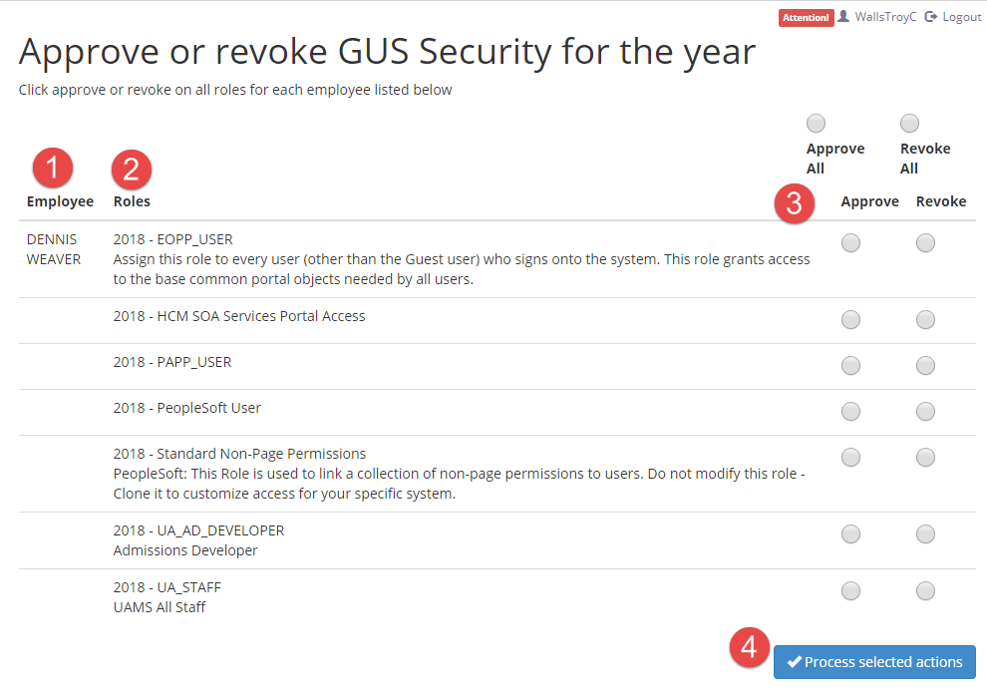

1. Employee name(s)
2. GUS user roles
3. **Approve** or **Revoke** roles
4. Process all selections

There are two options for approving/revoking roles: either **Approve All** or **Revoke All** at the top or make individual selections next to each employee/role.

Once you have made your selections, select **Process selected actions** at the bottom of the page and the system will log them. Employees with roles to be revoked with be processed within 2-3 days of your review.

You do not have to review all employees and roles at one time – you can process selections in increments until completed. Pending reviews will remain in your queue until approve or revoke selected and processed.

## Additional Information

If you have questions regarding GUS user roles, you have two options for additional information. At the top of the menu, you can access role descriptions by selecting **Role Definitions**. If you need further information on GUS security and roles, select **Additional Information** to be taken to the GUS information site.



**Role Definitions** will display the role, short and long description:

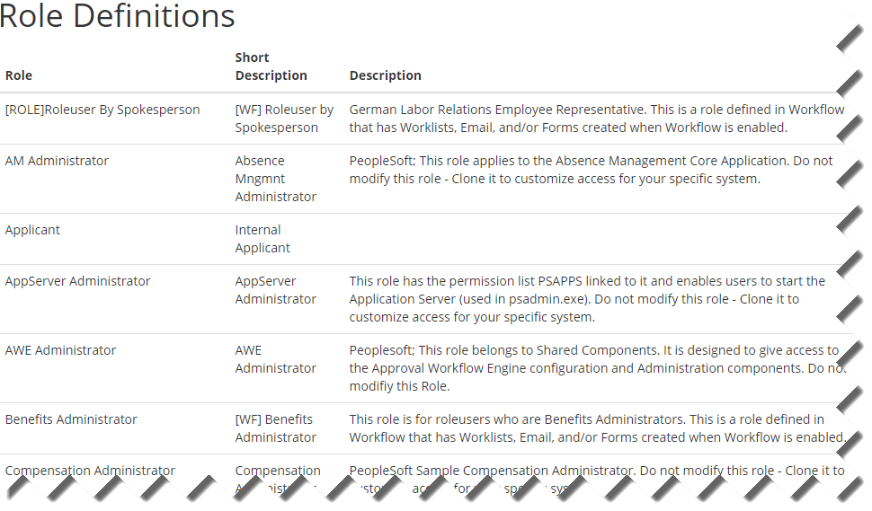

**Additional Information** will open a new tab for the GUS information page:

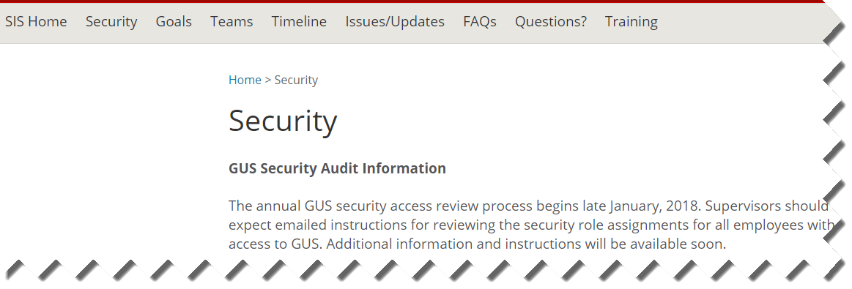

## Delegating and Reassigning Reviews

If you will be unable to complete your reviews in the scheduled time, you can delegate an UAMS employee to process reviews on your behalf. Additionally, if any employees are incorrectly assigned to you, you may have them reassigned to the correct supervisor.

To delegate or reassign, please contact IT Security at [Techsupportcenter@uams.edu](mailto:Techsupportcenter@uams.edu) and they will perform the actions on your behalf.