Scheduling Classes and Updating Class Instructors in GUS

Overview
If you are designated as the Class Scheduler by your college or department, you will have the ability to update the class schedule and the instructors in GUS. The following instruction guide provides information about the steps for making those updates or changes.

1. Log into GUS

1.1 Navigate to https://gus.uams.edu and log in using your UAMS Domain ID and password:
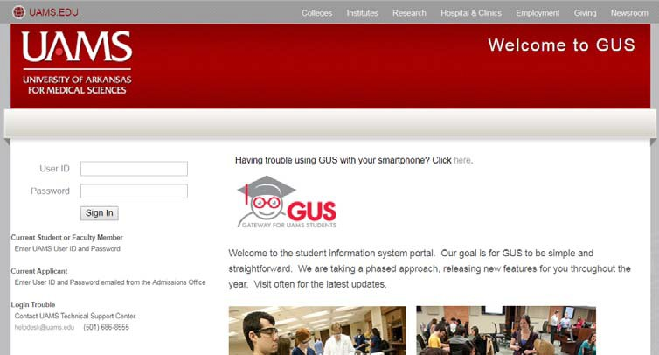

1.2 At the main GUS portal page, click the “Access To Gus” link to enter the system and access service indicators.
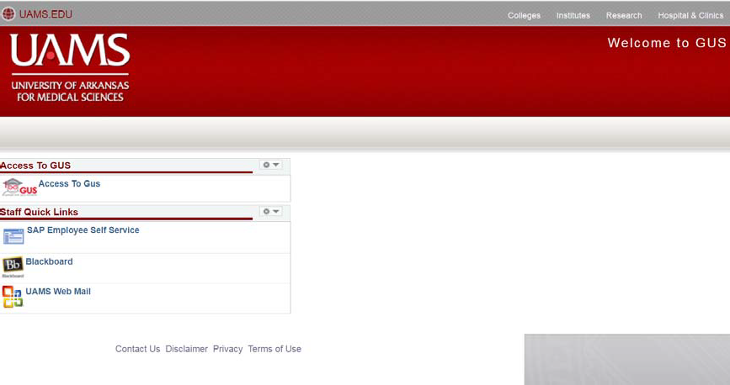

2. Adding, Deleting or Updating Instructors

At any time during an on-going semester, you can add, delete or update instructors from the classes in GUS. The changes that you made will be reflected in Blackboard almost instantly.

2.1 Using the path highlight below to navigate to the Schedule Class Meetings page. Remember, you may not have all of the same menu options as shown in the screenshot.

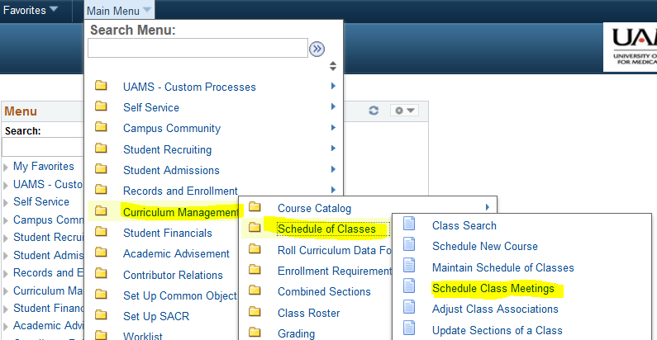

2.2 Search for the class(es) that you want to make the changes by entering the appropriate parameters under the Search Criteria section of the page. At the minimum, enter the first three criteria as shown in the screenshot below. The search results will be displayed after you click the “Search” button. Look through the list of classes displayed to identify the class that you would like to make changes, then click on the class to access the details.

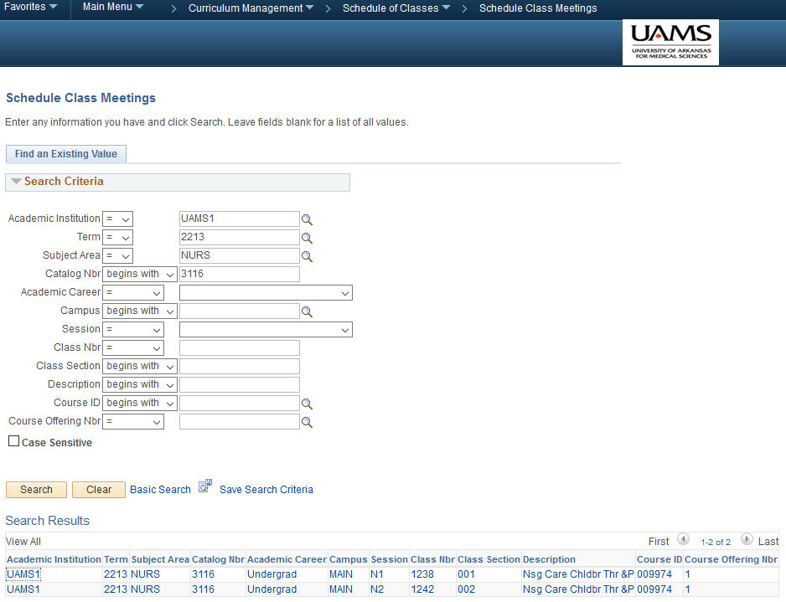
Search Results
Enter the search parameters here

2.3 On the Meetings tab, you can find the instructors who are currently assigned to the class and other related information such as their instructor roles, whether their names are printed on the schedule, whether they are designated as the Akademos person, and their grade access status. The default view only displays two instructors, to display all the instructors, click the “View All” link above the Akademos field.

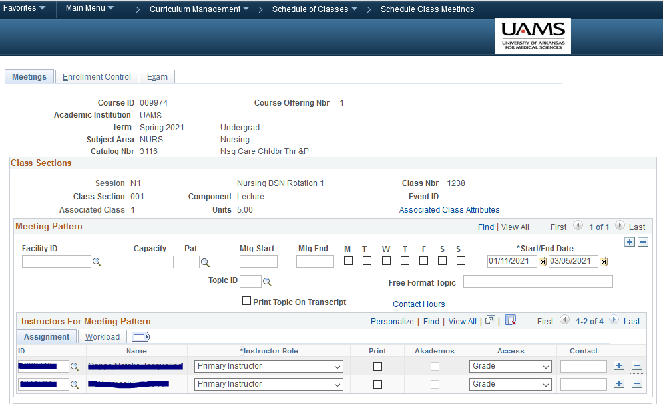
Click to view all the instructors for this class

2.4 To add an instructor to this class, use the [+] sign to add a blank row. Use the magnifying glass to look up the instructor from the list and select the correct instructor. Note: If the instructor that you want to add is not on the list, please contact OUR by emailing the instructor’s name, the class that he/she will be teaching and the SAP number (if available) to Registrar@uams.edu. The staff members at OUR will add the instructor and then notify you via email so you can add the instructor to the class.

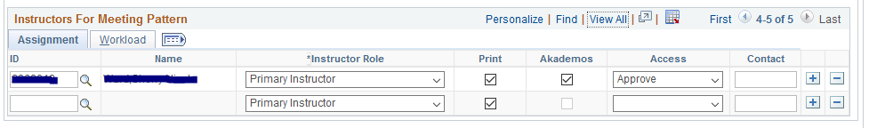

Then, assign the remainder of the information as appropriate:
a. Instructor role – The role you assigned will determine the person’s access in Blackboard. Use the following conversion chart to determine which role to assign to the instructor:
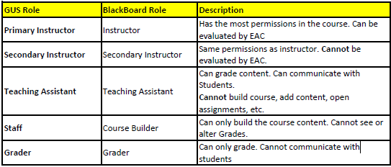
b. Print – By checking this box, the instructor’s name will display on Schedule of Classes in the Student Center when they search for the class. Generally, only the Primary Instructor will have the Print box checked.
c. Akademos – By checking this box, you designated the person as the Book Manager for Akademos. Only one person can be selected for this role. Generally, this is the Primary Instructor of the course. To make changes, you will first un-check the existing person and then check the new person.
d. Access – This will determine if the instructor has access to Grade or Approve grades for this class. DO NOT assign the option of “Post”. This is strictly used by OUR.
e. Click SAVE at the bottom of the page to confirm the changes.

2.5 To remove an instructor from this class, use the [-] sign to remove row. It is important to keep in mind that once an instructor is deleted from the course, he/she will no longer have access to course shell in Blackboard. Make sure to save the changes by clicking the Save button at the bottom of the page.

